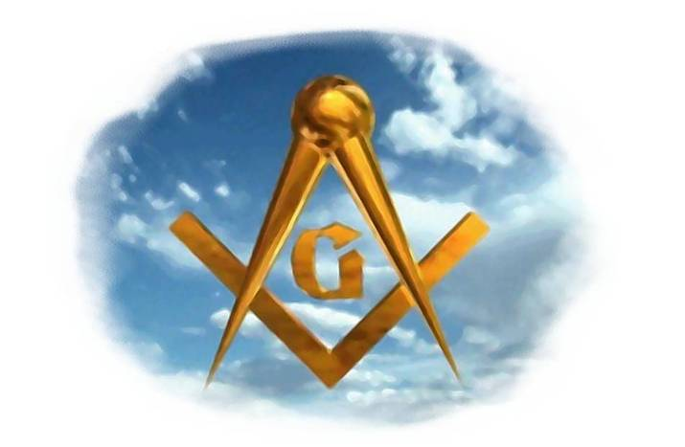
Orators Report
on the Feast of Tishri
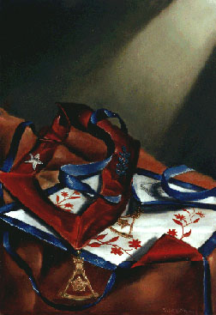
Every October
Dinner, Program and, the Dedication of
King Solomon's Temple
14th Degree

Bremerton Valley of the Scottish Rite
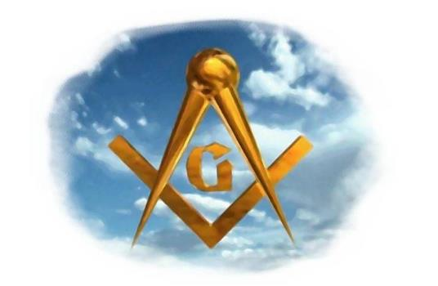
The Allegory: Sukkot, the Hebrew celebration, is the origin of the Feast of Tishri and traces its roots to the Book of Leviticus (23:39) where it is said that the Lord spoke unto Moses saying that on the fifteenth day of the seventh month when, "ye shall have gathered in the fruit of the land, ye shall keep a feast unto the LORD seven days .... [and] Ye shall dwell in booths (or tabernacles) seven days..... that your generations may know that I made the children of Israel to dwell in booths, when I brought them out of the land of Egypt."
The Setting: October is the Hebrew month of Tishri, or Tishrei. The month of Tishri has three Jewish holidays: Rosh Hashanah, Yom Kippur, and Sukkot. Sukkot, also called the Feast of Tabernacles, commemorates the forty-year period during which the children of Israel were wandering in the desert, living in temporary shelters. Sukkot is also a harvest celebration. Years ago fruit pickers would build shelters to sleep in during the harvest. Today Jewish families erect temporary shelters in their gardens, homes and in the synagogues.
The Ritual: The rich legendry of the Temple's dedication, which is celebrated in the Feast of Tishri, is an essential part of the Fourteenth Degree. It is divided into two parts: the conduct of the Lodge with a following feast of celebration and its appropriate ceremonies.
The Toast of Obligation given during the Feast is obligatory. The program and menu may be varied as fits the needs of the individual Lodge of Perfection. A proper flexibility of the celebration allows the maximum benefit for the Brethren while sustaining the core of tradition and form.
According to established custom, the Lodge of Perfect Elus meet in its usual place of assembly. Then the officers or Brethren so designated open the Lodge in full or short form. After the Lodge has been opened, the Venerable Master, the Secretary, or some other Brother who has been selected for the honor reads “Why the Feast of Tishri?” (This may be read at the dinner.)
Following the reading, a Brother respected for his eloquence and clarity reads aloud the Obligation of the Fourteenth Degree of the Scottish Rite so that all the Brethren can hear and respond again to the responsibilities they have gladly accepted as Brethren of the Mystic Tie.
The Brethren then join in Prayer, requesting guidance and inspiration befitting this great feast day.
The Lodge is then closed in full or short form.
After the Lodge of Perfection has been officially closed, the Brethren join their guests at the banquet hall and enjoy the Feast.
The Lecture: Freemasons have always revered order since we recognize that there is a Supreme Order that structures all creation. Masonic Law reflects this divine order, and we serve the purposes of the Great Architect of the Universe when we observe this vow of obedience to the Rite.
Significantly, Solomon, a king of peace and wisdom built the Temple. The Lord forbade David, a warrior and a man of blood, to construct the Temple and, instead, delivered this responsibility and glory to Solomon whose very name means peace. Thus in observing the Feast of Tishri we reaffirm our dedication to human concord and brotherhood of all men in a world of peace. As individuals and as Brothers in the Rite we resolve to build, as Solomon did, through harmony and cooperation ever seeking peace for all mankind.
The law, legendry, peace, equality, unity and fellowship of the Feast of Tishri combine to make this the Masonic feast of feasts. At the Reflection Table all men --Jew, Christian, Muslim, Buddhist, and others -- join in a common voice of thanksgiving to God. The Feast of Tishri is a Masonic Feast of Thanksgiving where every man can share his gratitude and express his sincere thanks to Him Who made all things.

The Scottish-Rite-Masonic Feast of Tishri celebrates the dedication of King Solomon's Temple. The origins and significance's of the Feast of Tishri make it the most “Scottish Rite” of Festivals. No other occasion epitomizes the character and purpose of the Rite more wholly than this historic celebration of the dedication of King Solomon's Temple. To marshal the meanings of the feast is to summarize the principle ideals and traditions of our Fraternity.

DUTIES: We observe the Feast of Tishri because it is an age-old custom, which now has power of law. Under the Statutes of The Supreme Council the Feast is "obligatory," a sacramental sharing of our fraternal spirit.

LESSONS and SYMBOLS: The symbolic details of the Temple's position, design, construction, furnishing and decoration carry intense meaning as they apply to the spiritual temple of Freemasonry built in the soul of every Brother. Through the symbols of the Temple we gain enlightenment and we recommit ourselves to building Freemasonry "in the hearts of men and among nations."

TOASTS OF OBLIGATION:

- To the President and the United States of America.
- Supreme Council
- Sovereign Grand Commander ILL Ronald A. Seale
- MW Grand Lodge and Grand Master of F&AM of Washington
- Sovereign Grand Inspector General ILL. William R. Miller
- Other Grand Bodies of WA
- Departed Brethren
- Our Armed Forces
- Our Fraternity, Masons, and Masonic Bodies, of all Rites and Degrees, across the world: acclaim to the worthy; restoration to the ill; help to the needy; and succor to the oppressed of all nations.

Adapted from Forms and Traditions of Scottish Rite" 2000 C. Fred Klienknecht

